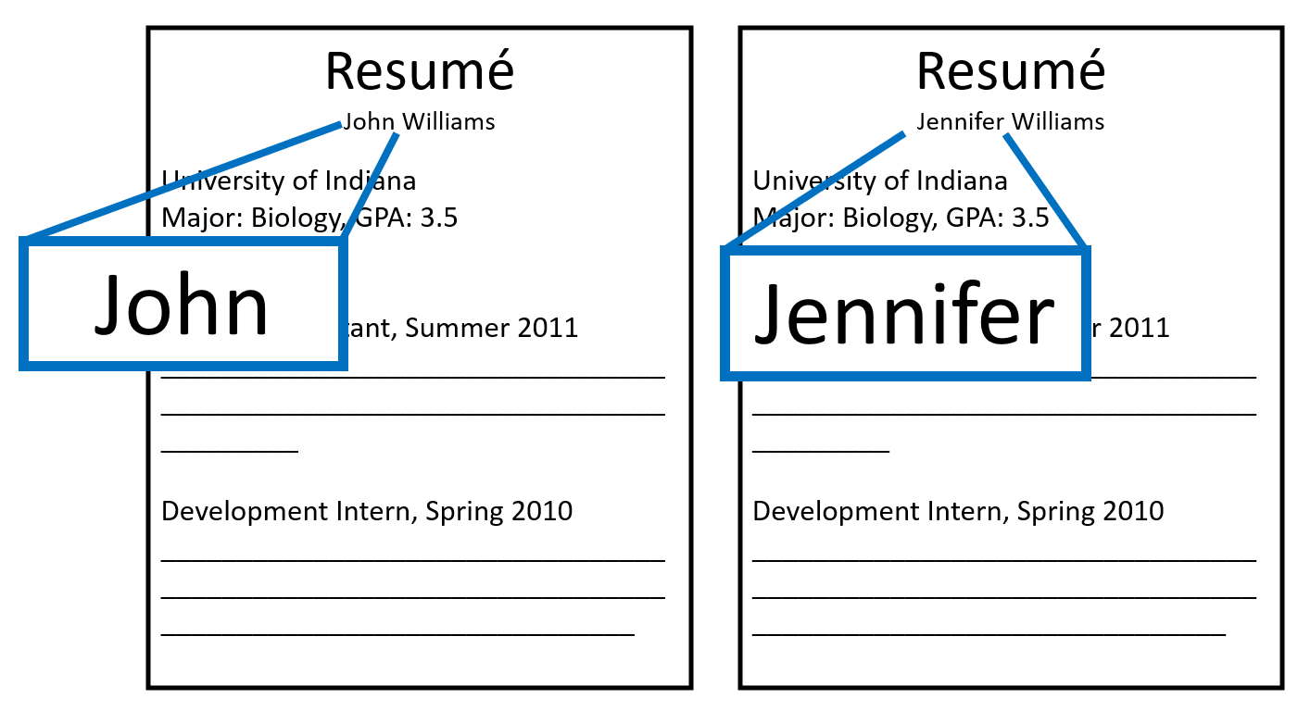**The Jenn/John Study**

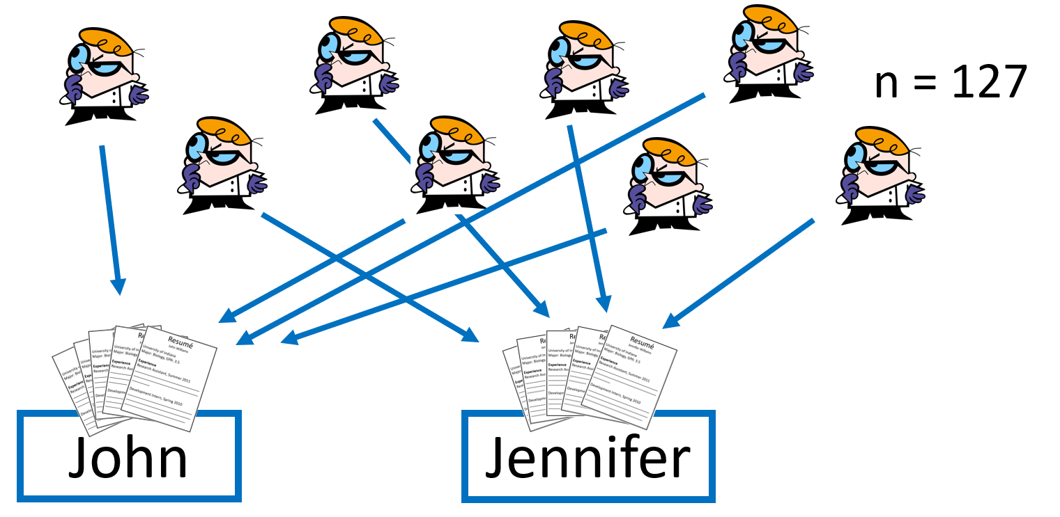In this study*, experimenters printed up copies of fake application materials for a science lab manager job. All copies of the application materials were completely identical, except for one thing: the name. On about half of the copies, the application listed the name “John.” The other half had the name “Jennifer.” Experimenters found 127 science lab faculty members and randomly sent them either a “John” (n = 63) or “Jennifer” (n = 64) application. Each faculty member was told that the application was for a real position at their University. The faculty members independently rated the applicant’s “hireability” (1-7 scale) and estimated their starting salary. Experimenters compared these results across the two groups.

***The experiment described above is a…***

Completely randomized design:

An experimental design in which experimental units are assigned to treatments completely at random.

* This is the ________ of experiments – the simplest (but still effective) randomized experiment.

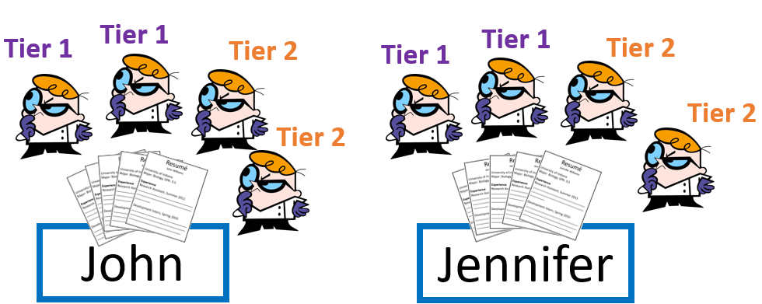

**What if the faculty members were from both Tier 1 and Tier 2 Universities?**

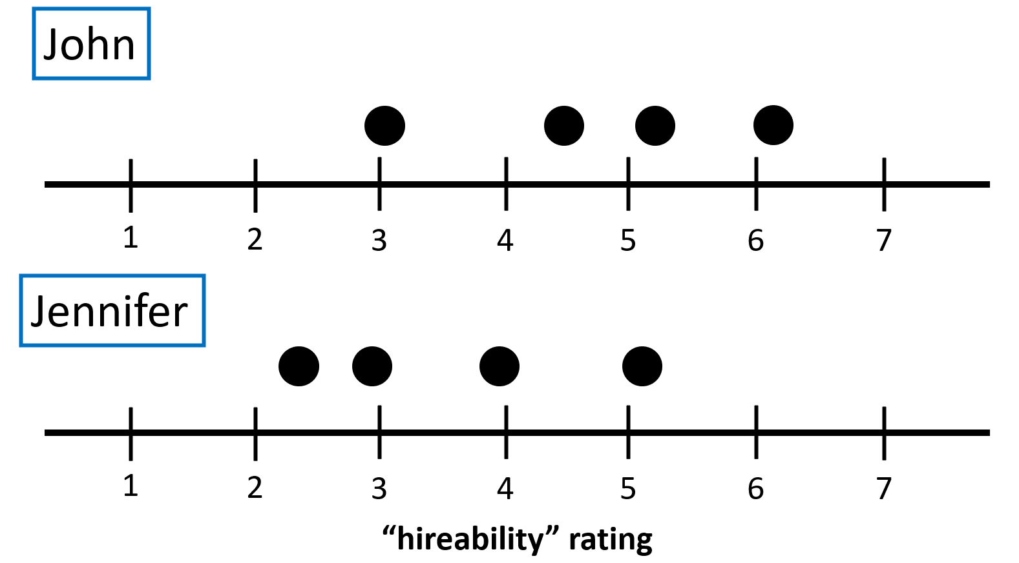

There is some difference but also some overlap.

The differences may be due to _____________________.

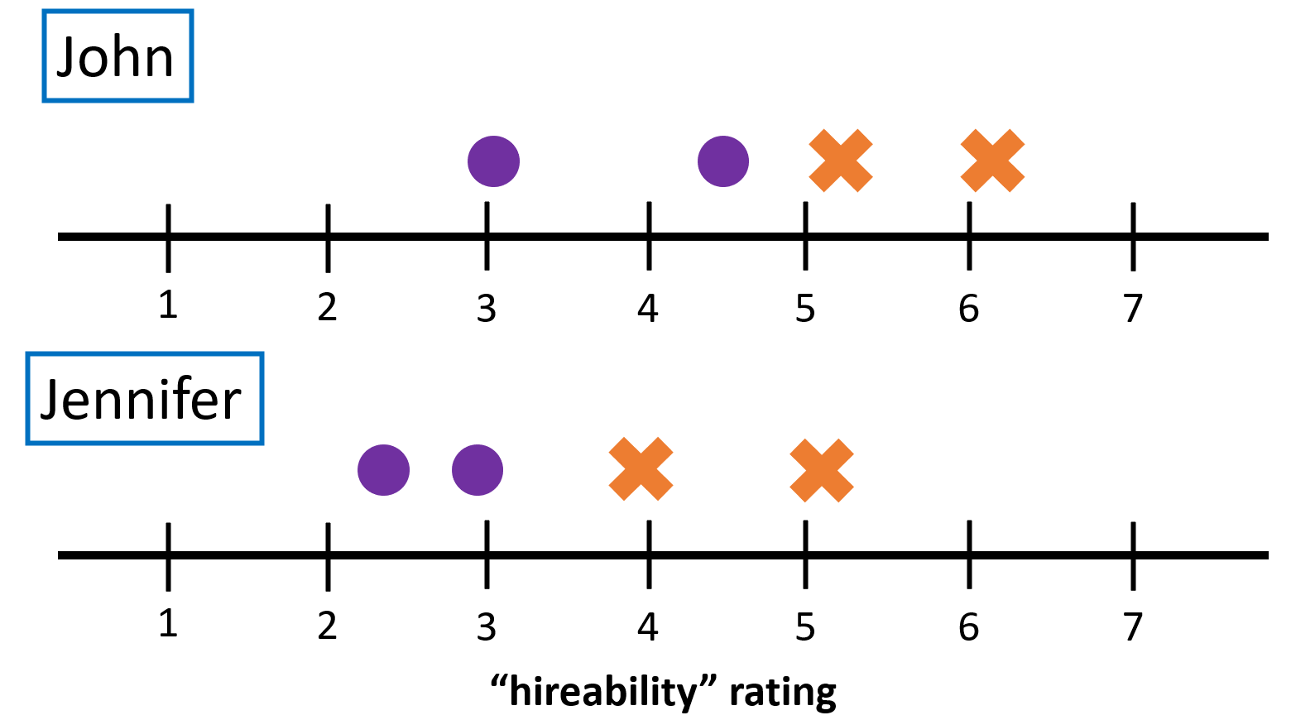

When broken down by Tier, there is little overlap.

Schools ____________ each tier rated John more ‘hireable.’

**Blocking**

**How to reduce the variability due to school tier:**

Randomized Complete Block Design: experimental units are first blocked (_________________) by a similar trait that may affect response. Then, units from each block are randomly assigned to treatment.

* This is the _______________________________ of experiments.
* It reduces variation between treatment groups at the start of the experiment. This makes it easier to show that differences in response are really _______________________________, rather than chance variation in the random assignment.

**Question:**Describe how you would implement a randomized complete block design for the Jenn/John study, which takes into account University tier.

*Model Response:*

“Block the science lab faculty members by University tier. In each block, assign each faculty member ______________. For the Tier 1 block, write all the numbers on identical slips of paper, put into a hat, and mix well. Draw out 3 slips of paper, _____________________________________.The corresponding faculty are assigned ‘Jennifer’ application materials. The remaining are assigned ‘John’ materials. _______________ the same random assignment process for the Tier 2 block. Compare ‘hireability’ ratings between the Jenn/John groups ____________ each block. ____________________ the results, after accounting for the average difference in each block.”

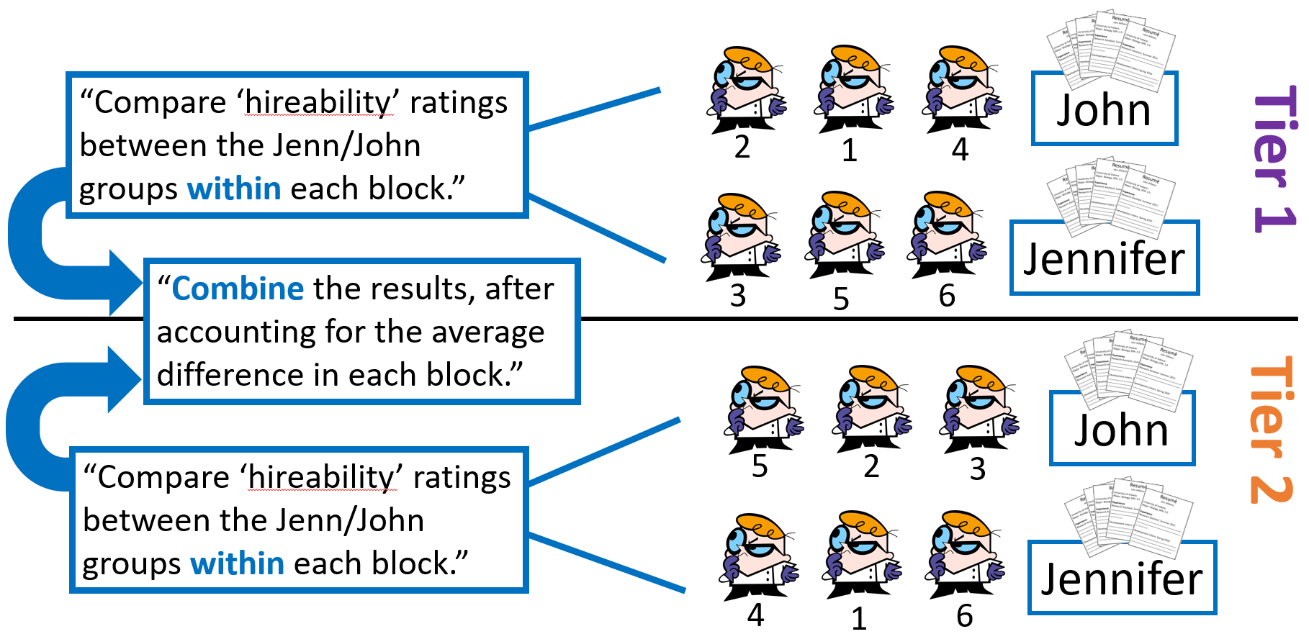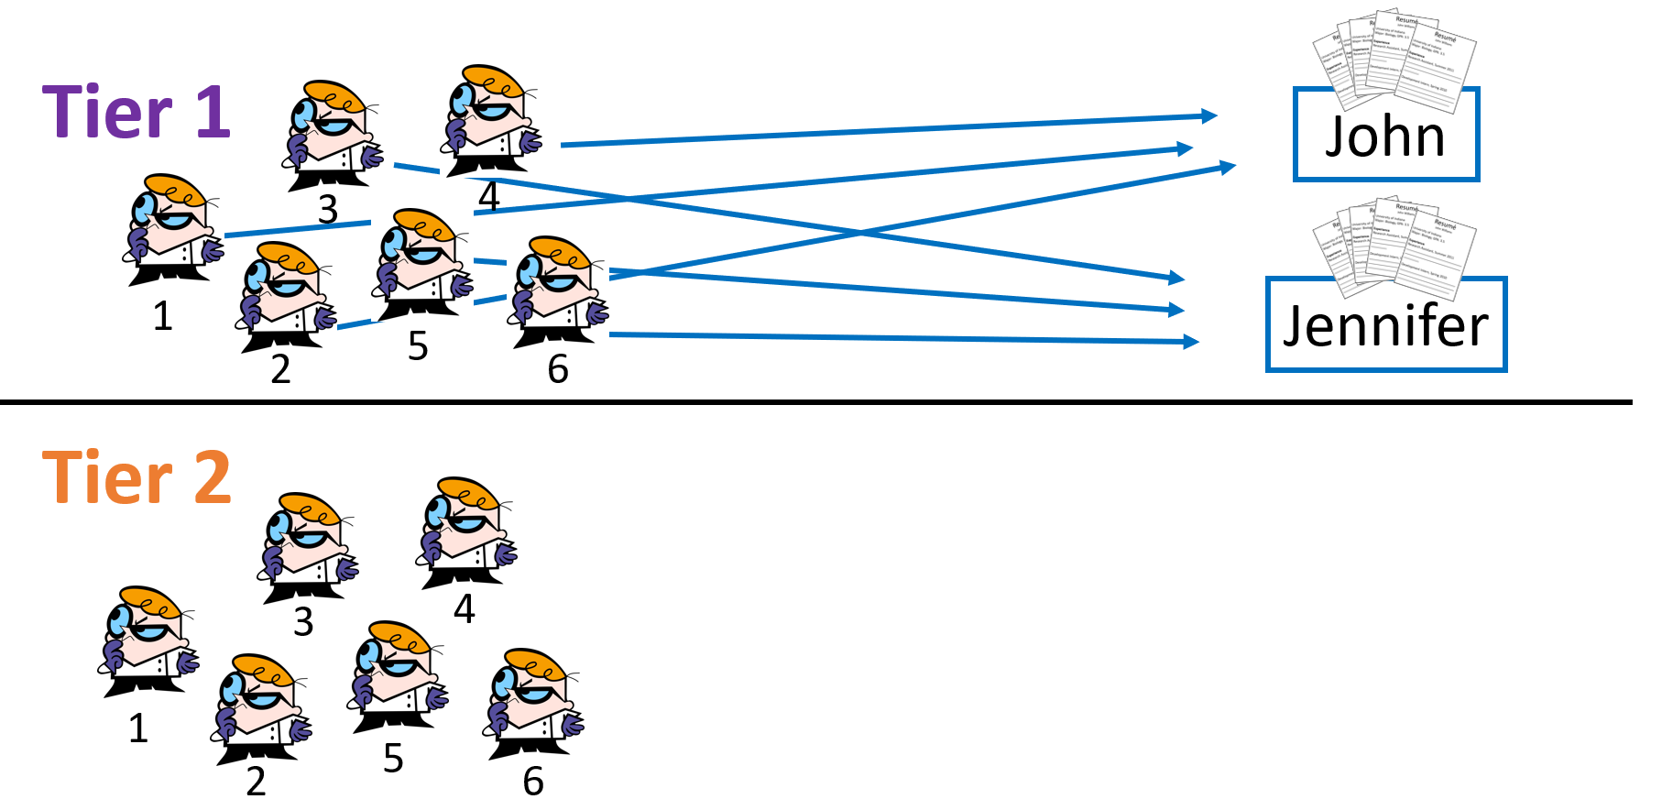

**Matched Pairs Design**

Matched Pairs Design: a type of randomized blocked experiment in which each block is composed of similar experimental units (a “matched pair”).

* Often, the “matched pair” is simply the same experimental unit receiving both treatments. The of the treatments is randomized.

**The 2015 *Journal of the American Medical Association* Depression Study**

In this study*, researchers wanted to test if taking a “fake pill” would actually alleviate depression symptoms, even though the pill had no active ingredients. 35 people enrolled in the study. All had major depression and none were taking any medications. Because depression varies greatly between individuals, the researchers implemented a matched pairs design.

*\*Simplified version of: Association Between Placebo-Activated Neural Systems and Antidepressant Responses: Neurochemistry of Placebo Effects in Major Depression. Peciña M, Bohnert AS, Sikora M, Avery ET, Langenecker SA, Mickey BJ, Zubieta JK. JAMA Psychiatry. 2015 Sep 30:1-8. doi: 10.1001/jamapsychiatry.2015.1335. [Epub ahead of print]. PMID: 26421634.*

**Question:**Describe how you would implement a matched pairs design for the depression study.

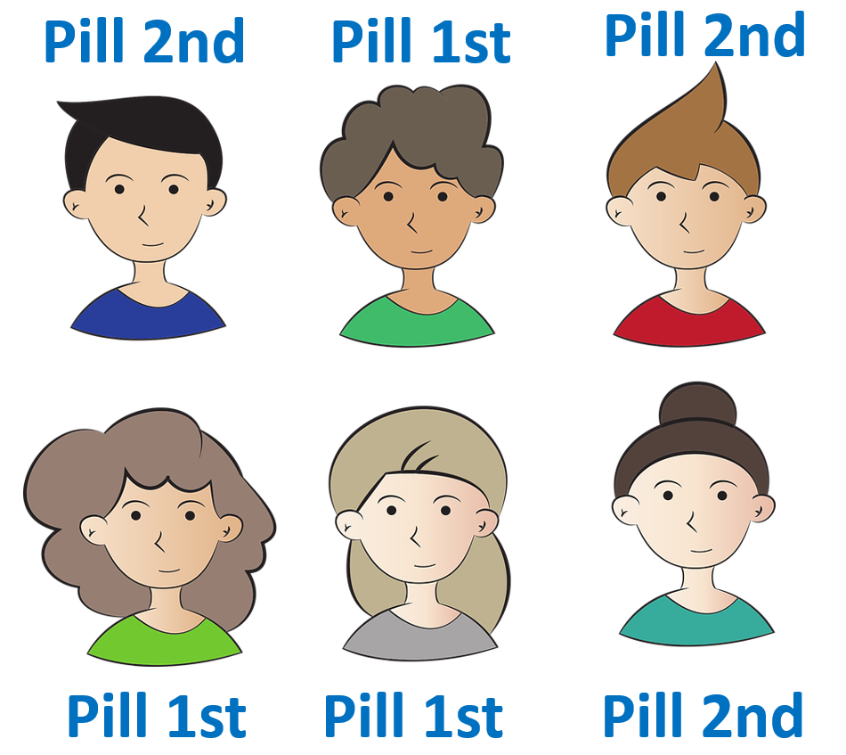

“For each subject, flip a coin. Heads indicates they get the fake pill for the first week, no pill for the second week. Tails indicates the _____________________________________. Have each subject fill out a depression questionnaire and undergo a PET brain scan at the end of each week. Compare measurements _________________________and compile the results.”

**Depression study results**

1. On average, participants reported less severe depressive symptoms after their week with the fake pill.
2. On average, participants showed “increased µ-opioid receptor brain activity in regions of the brain associated with emotion and stress regulation.”
   * **Belief in the pill caused a *____________________________***

“Fake pills” have also have also shown significant beneficial effects for….

* Migraines
* Blood Pressure

Called the:

_______________________

* Asthma
* Arthritis
* Many other ‘physical’ illnesses

**Source:** <https://www.ncbi.nlm.nih.gov/books/NBK513296/>

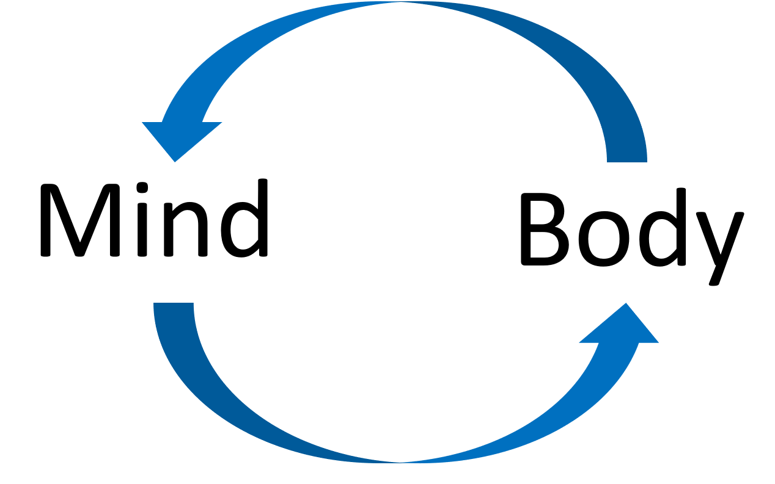**Blinding and Placebo**

Placebo: An________________treatment (e.g. sugar pill or salt water IV drip)

Placebo effect: when subjects’ belief of receiving an active treatment leads to a measured response, even though the treatment is ___________________________.

Single-blind study: _______________ the subjects or the researchers are unaware of who receives active treatment or placebo.

Double-blind study: ________ the subjects and the researchers are ___________________ of who receives active treatment or placebo.

Why blind subjects:

Why blind researchers:

* Researchers trying to prove that a treatment works may favor treatment group in their measurements

**Generalization and Scope of Inferences**

|  |  |  |
| --- | --- | --- |
|  | Subjects **were** randomly assigned to groups (experiment) | Subjects **were not** randomly assigned to groups (observational study) |
| Subjects **were** randomly sampled from the population | Generalize to the population: ___  Determine cause and effect: ___ | Generalize to the population: ___  Determine cause and effect: ___ |
| Subjects **were not** randomly sampled from the population | Generalize to the population: ___  Determine cause and effect: ___ | Generalize to the population: ___  Determine cause and effect: ___ |

**Were subjects randomly assigned to treatment?**

**Were subjects randomly sampled?**

